**News Tracker Application PNT2022TMID45109**

**Setting up Application Environment**

**Docker CLI Installation**

**Step 1**. Download Docker from docker.com and install it by running the Docker Desktop Installer.exe file

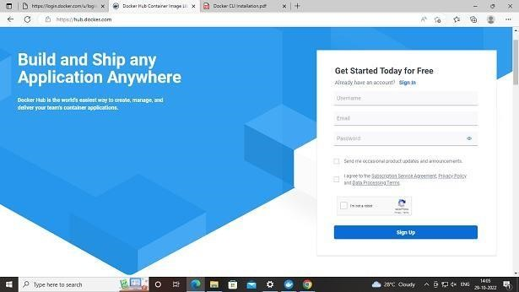

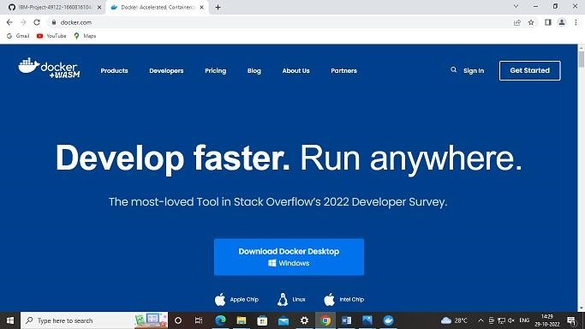

**Step 2**. Goto hub.docker.com register and create an account and login with the same

**News Tracker Application PNT2022TMID45109**

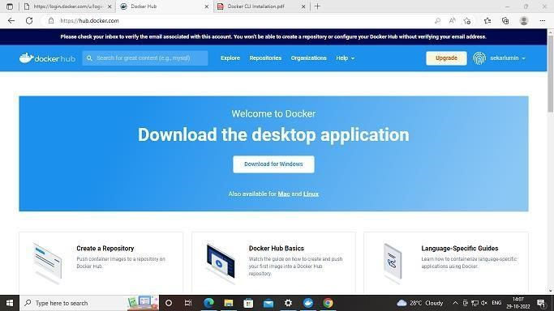

**Step 3**. Open Docker Desktop and start creating containers and images

